Call for Papers

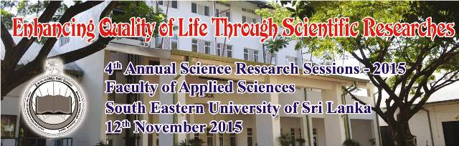

The Fourth Annual Science Research Sessions 2015 organized by the Faculty of Applied Sciences, South Eastern University of Sri Lanka, Sammanthurai is going to be held on 12th November 2015.

The research sessions will be a science based multidisciplinary conference where the research papers will be presented under different research tracks.

The sessions aims to bring together leading researchers, scientists, academics and research students from various universities and institutions of the island to exchange and share their knowledge and research experience about all aspects of Science.

Key Tracks
- Agriculture
- Biology
- Chemistry
- Computer Science & IT
- Environmental Sciences
- Interdisciplinary Sciences Statistics
- Mathematics
- Physics

Extended abstracts should be submitted electronically in Microsoft Office word format as an e-mail attachment to asrs_2015@fas.seu.ac.lk on or before 18th September 2015.
All accepted abstracts will be published in the proceeding after peer review.
Organizing Committee
Chairperson: Dr. (Mrs.) M.I.S. Safeena,
Dean/ Faculty of Applied Sciences,
South Eastern University of Sri Lanka.
Co-ordinator: Mr. M.F. Nawas
Chief Editor: Mr. M.J.M. Jafeen
Co- Editor: Dr. M.H. Haroon
Secretary: Mr. M.A.A.M. Faham
Treasurer: Mr. T. Jaseetharan
Member: Mr. A.L. Hanees

Submission
- Manuscripts should be prepared according to the guidelines.
- Author has to clearly indicate the key tracks.
- All manuscripts and presentation must be in English.
- An electronic version of the extended abstract and abstract should be mailed to reach the ASRS Secretariat on or before 18th September 2015.

Guidelines for preparing extended abstract & abstract
Format: Microsoft Word (2003 or latest)
Font: Times New Roman
Title: Font size 14 bold, with only initial letters in capital
Name of the authors: Font size 12 regular, surname/last name with initials (in capital)
Affiliation: Font size 11 regular, In case the affiliations of authors are different, indicate using superscripts in Arabic numerals
Text: Font size 12 with double spacing. The extended abstract should not exceed six (06) A4 size pages.
Figures/ tables may be included only if unavoidable.

Registration Fee
Registration fee covers
- Participation in the Session
- A printed copy of the Session program
- A copy of the printed proceedings
- Symposium Kit
- Certificate
- Lunch & Refreshments

Local Participants………………………LKR 3000.00
SEUSL Staff…………………………………LKR 2000.00
Postgraduate Students………………..LKR 1500.00
Undergraduate Students……………..LKR 1000.00
Method of Payment
Payment can be made by depositing cash or sending a Bank Draft. Payment should be made to the following Account Number in favor of “South Eastern University of Sri Lanka”
Account No: 064-1-001-7-0000025, Peoples’ Bank, Sammanthurai.

Contact

4th Annual Science Research Sessions – 2015(ASRS 2015)
Faculty of Applied Sciences,
South Eastern University of
Sri Lanka,
Sammanthurai.
32200

E-mail: asrs_2015@fas.seu.ac.lk
Coordinator: Mr. M.F. Nawas
Department of Physical Sciences
Faculty of Applied Sciences
South Eastern University of Sri Lanka
0777900946

Secretary: Mr. M.A.A.M. Faham
Department of Mathematical Sciences
Faculty of Applied Sciences
South Eastern University of Sri Lanka
0776168903

